**Team BWES**

**Capstone Design II: EG499**

**27 April 2021**

**Southern New Hampshire University**

**Manchester, NH**

**Project Engineers:**

**Ryan Waterman:**[**ryan.waterman@snhu.edu**](mailto:ryan.waterman@snhu.edu)

**Wesley Kane:**[**wesley.kane@snhu.edu**](mailto:wesley.kane@snhu.edu)

**Gavin Myers:**[**gavin.myers@snhu.edu**](mailto:gavin.myers@snhu.edu)

**Wesley Tobin:**[**wesley.tobin@snhu.edu**](mailto:wesley.tobin@snhu.edu)

**Executive Summary**

The Bladeless Wind Energy System (BWES) is intended to provide a proof of concept to aid SNHU is navigating eco-friendly options for energy generation. The team had to design a system that would follow the works of Dr. Westergaard and his efforts in creating an efficient wind energy system. The BWES was designed with two airfoils as the focus of creating the necessary pressure zone to force air through the turbine, creating energy. The physical, environmental, and safety requirements were met; the performance requirements were not met, as a modified system was used to overcome startup torque issues of the original generator. Through lab testing, the turbine system proved functional. The final outdoor test resulted in the detection of wind speed and direction, but no power generation. After consideration and discussion among the team members and the customer (SNHU Professors), it was determined the location of installation was not ideal. The preliminary lab test proved that there does exist a wind speed capable of causing energy generation from our system. In conclusion, the performance requirements were not met in final testing; these may be met with a more desirable location with less variable topography or open area. The team gained invaluable experience from this project, as the complexities of such a system challenged the team’s engineering skills learned from Southern New Hampshire University that resulted in creating the BWES prototype.

Table of Contents

**I.** **Introduction** 6

a. Mission and Purpose 6

b. Background 6

c. Concept of Operations 7

**II.** **System Requirements** 8

**III.** **Chosen Design** 11

**IV.** **Subsystems** 16

a. Airfoils 16

b. Manifold 27

c. Turbine 29

d. Generator Circuit 31

e. Code 34

**V.** **Fabrication and Integration** 38

a. Table 38

b. Roof 40

c. Airfoils 41

d. Manifold 44

e. Turbine 45

f. Generator Circuit 47

g. Code 49

**VI.** **Final System Test Results and Discussion** 51

**VII.** **Conclusion and Lessons Learned** 57

**VIII.** **Recommendations for Continuing Project Work** 58

**IX.** **Appendices** 59

a. Appendix A:  Schedule 59

b. Appendix B: Financial Summary 60

c. Risks and Mitigations 61

d. Code 62

**X.** **References** 66

**List of Figures**

Figure 1: CONOPS 7

Figure 2: Preliminary Conceptual Design 11

Figure 3: Completed Prototype 11

Figure 4: XFLR5 Airfoil Design Iterations 17

Figure 5: XFLR5 Iterative Analysis of Airfoils 1-5 17

Figure 6: Coefficient of Pressure at 0° Angle of Attack 19

Figure 7: Velocity at 0° Angle of Attack 19

Figure 8: Coefficient of Pressure at 5° Angle of Attack 20

Figure 9: Velocity at 5° Angle of Attack 20

Figure 10: COMSOL vs. XFLR5 Coefficient of Pressure for 5° Angle of Attack 21

Figure 11: 45% Chord Length Spacing at 5° AoA 22

Figure 12: 55% Chord Length Spacing at 5° AoA 23

Figure 13: 65% Chord Length at 5° AoA 23

Figure 14: Scale Airfoil Model 24

Figure 15: Wind Tunnel Airfoil Model Testing 25

Figure 16: Wind Tunnel Test Results 26

Figure 17: Turbine Blade Design 30

Figure 18: 12V Deep Cycle Battery 31

Figure 19: Complete Electrical Schematic 32

Figure 20: Wind Direction Code Flow Design 35

Figure 21: Wind Speed Code Flow Design 36

Figure 22: Table 39

Figure 23: Completed and Installed Roof 40

Figure 24: Completed Airfoils 43

Figure 25: Completed Manifold System 44

Figure 26: Completed Turbine System 46

Figure 27: Electrical Circuit Placement 47

Figure 28: Voltage and Current Code Snippet 50

Figure 29: North Component Calculation Graph 53

Figure 30: BWES Installation Location 55

Figure 31: Code 1/4 62

Figure 32: Code 2/4 63

Figure 33: Code 3 / 4 64

Figure 34: Code 4/4 65

**List of Equations**

Equation 1: Conceptual Remin 13

Equation 2: Conceptual Remax 13

Equation 3: Analytical Remin 13

Equation 4: Analytical Remax 13

Equation 5: Coefficient of Pressure 15

**List of Tables**

Table 1: Performance Requirements 8

Table 2: Physical Requirements 8

Table 3: Functional Requirements 9

Table 4: Environmental Requirements 10

Table 5: Safety Requirements 10

Table 6: Generator Type Trade-off 12

Table 7: Location Trade-Off Matrix 14

Table 8: BWES Installation Location 15

Table 9: Final System Test Data 52

Table 10: Calibrated North for Final Test 54

Table 11: BWES Budget 60

Table 12: System Risks and Mitigations 61

# **Introduction**

## Mission and Purpose

The Bladeless Wind Energy System (BWES) will provide a proof of concept to SNHU to help them navigate eco-friendly energy generation options. The BWES, unlike other conventional turbines, uses a different method to turn the turbine blades. Instead of pure wind strength in turning the blades, the BWES utilizes the creation of a low-pressure zone from the designed airfoils. This low-pressure zone created by the airfoils pulls air through the manifold, where the turbine blades are stored. This flow of air causes the turbine to turn; thus, the BWES is coined a “bladeless” system as there is no external blades that can harm wildlife. Traditional wind energy generation systems are commonly criticized for their size, noise production, and negative affect on wildlife. The BWES team hoped that this proof of concept would help SNHU in creating a carbon-neutral campus by the year 2025.

## Background

This project was inspired by the works of Dr. Westergaard and his unique wind energy system. The idea was brought forth by the customer as a capstone idea, and the team now known as BWES took on the project. The central idea of Dr. Westergaard’s system was that pressure was the key component in creating the wind speed for turning the turbine. Conventional wind energy turbines are extremely large, noisy, and have been known to harm wildlife. The wind itself is what turns the large blades of these systems. That is why Dr. Westergaard’s idea and system can potentially alter the course of wind energy generation development in the future. The BWES system is an attempt to model his system in a similar fashion when it comes to using the idea of the pressure differential; however, the BWES team designed different airfoils, manifolds, and turbine blades.

## Concept of Operations

The conceptual operation of the BWES is to cause wind flow through the manifold caused by the low pressure change near the airfoils. The system itself has five subsystems: airfoils, manifolds, turbine, generator circuit, and code. While all the listed subsystems play an important role in the system, the airfoils are the most complex when it comes to simulation, fabrication, analysis, and performance. Later in this report, the analysis of these airfoils will be discussed in detail, along with the other subsystems and their designs and analysis.

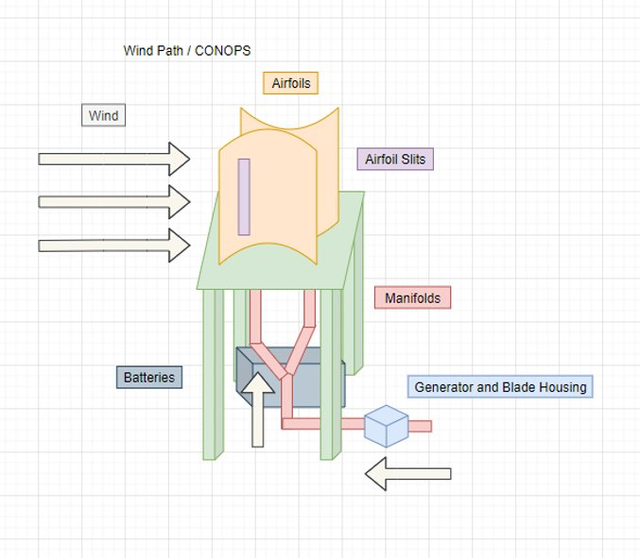

Figure 1: CONOPS

The diagram above shows the system with the different elements labeled. The airfoils create a low-pressure zone from the incident wind flowing past them, which then causes wind to be pulled through the lower manifolds. The generator is mounted in this flow path, utilizing the pressurized airflow to turn the turbine blades.

# **System Requirements**

|  |  |  |  |  |  |  |
| --- | --- | --- | --- | --- | --- | --- |
| **Requirement**​  **Group​**​​ | **Item ID​**​​ | **Title​**​​ | **Statement​**​​ | **Parent**​  **Source​**​​ | **Verification**  **Method​**​​ | **Status**​ |
| **BWES**​  **Performance​**​​  **Requirements​**​​ | ​​​ | ​​​ | ​​​ | ​​​ | ​​​ | ​​​ |
| **Performance​**​​ | BWES-01​​​ | BWES Wind Intake​​​ | The BWES shall be capable of  generating electrical ​  energy with a ​  minimum atmospheric ​  wind strength of 2.5 m/s.​​​ | Research​​​ | Test​​​ | Met​ |
| **Performance​**​​ | BWES-02​​​ | BWES Electrical  Output​​​ | The BWES shall be capable of  generating 50W-400W of power. ​​​ | Research​​​ | Test​​​ | Not met (modified system) |

Table 1: Performance Requirements

|  |  |  |  |  |  |  |
| --- | --- | --- | --- | --- | --- | --- |
| **Requirement Group​**​​ | **Item ID​**​​ | **Title​**​​ | **Statement​**​​ | **Parent Source​**​​ | **Verification Method​**​​ | **Status**​ |
| **BWES**  **Physical ​**​​  **Requirements​**​​ | ​​​ | ​​​ | ​​​ | ​​​ | ​​​ | ​​​ |
| **Physical​**​​ | BWES-03​​​ | BWES Airflow ​  Manifold Design​​​ | The BWES shall utilize  airfoils that connect to the  manifolds. ​​​ | ConOps​​​ | Inspection​​​ | Met​ |
| **Physical​**​​ | BWES-04​​​ | BWES Dimensions​​​ | The BWES system's outline  dimensions shall not exceed 5m (X) x 5m (Y) x 3m (Z)​​​ | ConOps​​​ | Inspection​​​ | Met​​​ |

Table 2: Physical Requirements

|  |  |  |  |  |  |  |
| --- | --- | --- | --- | --- | --- | --- |
| **Requirement Group​**​​ | **Item ID​**​​ | **Title​**​​ | **Statement​**​​ | **Parent**  **Source​**​​ | **Verification**​  **Method​**​​ | **Status**​ |
| **BWES Functional ​**​​  **Requirements​**​​ | ​​​ | ​​​ | ​​​ | ​​​ | ​​​ | ​ |
| **Functional​**​​ | BWES-05​​​ | BWES "Bladeless"  Design​​​ | The BWES shall be designed such that air flows through the ​  manifolds and internal ​  turbine generator. ​​​ | ConOps​​​ | Inspection​​​ | Met​  ​ |
| **Functional​**​​ | BWES-06​​​ | BWES Energy Storage​​​ | The BWES turbine ​  Generator shall be ​  capable of charging ​  two external 12V 100aH deep cycle  batteries. ​​​ | Research​​​ | Demonstration​​​ | Met with modification​ |
| **Functional​**​​ | BWES-07​​​ | BWES Charging  System​​​ | The BWES generator's​​​  24V AC 3-phase output ​  will be connected to a ​  24V battery controller ​  and converted to 24V DC. ​​​ | Research​​​ | Demonstration​​​ | Met with modification​ |
| **Functional​**​​ | BWES-08​​​ | BWES Energy  Generation​​​ | The BWES shall utilize ​  an internal permanent ​  magnet generator. ​​​ | ConOps​​​ | Inspection​​​ | Met​ |

Table 3: Functional Requirements

|  |  |  |  |  |  |  |
| --- | --- | --- | --- | --- | --- | --- |
| **Requirement**  **Group​**​​ | **Item ID​**​​ | **Title​**​​ | **Statement​**​​ | **Parent**​  **Source​**​​ | **Verification**​  **Method​**​​ | **Status**​ |
| **BWES**  **Environmental**​  **Requirements​**​​ | ​​​ | ​​​ | ​​​ | ​​​ | ​​​ | ​​​ |
| **Environmental​**​​ | BWES-09​​​ | BWES Effective ​  Environment​​​ | The BWES shall be capable of ​  Operating constantly in a  location with a high average wind speed (on top of a building). | ConOps​​​ | Demonstration​​​ | Met​ |
| **Environmental​**​​ | BWES-10​​​ | BWES Extreme ​  Environment​​​ | The BWES shall be capable of ​  withstanding expected ​  environmental stress​  such as snowfall ​  (68in/year) and ​  wind ( > 25 mph). ​​​ | Research​​​ | Demonstration​​​ | Met​ |

Table 4: Environmental Requirements

|  |  |  |  |  |  |  |
| --- | --- | --- | --- | --- | --- | --- |
| **Requirement**  **Group​**​​ | **Item ID​**​​ | **Title​**​​ | **Statement​**​​ | **Parent**​  **Source​**​​ | **Verification Method​**​​ | **Met​**​​ |
| **BWES Safety**​  **Requirements​**​​ | ​​​ | ​​​ | ​​​ | ​​​ | ​​​ | ​​​ |
| **Safety​**​​ | BWES-11​​​ | BWES Coverage​​​ | The BWES shall not ​  have any exposed ​  wires. ​​​ | ConOps​​​ | Demonstration​​​ | Met​ |
| **Safety​**​​ | BWES-12​​​ | BWES Shape​​​ | The BWES shall not​  have any sharp​  edges. ​​​ | ConOps​​​ | Demonstration​​​ | Met​ |

Table 5: Safety Requirements

1. **Chosen Design**

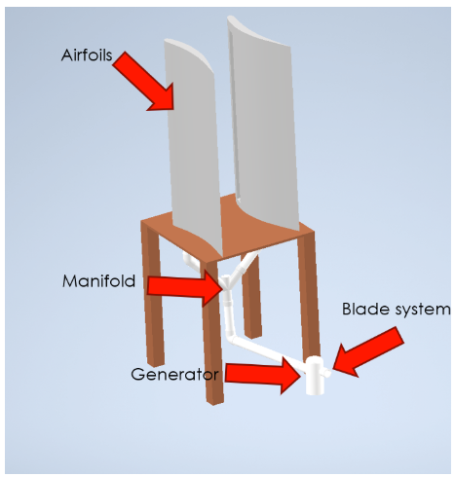

*Figure 2: Preliminary Conceptual Design*

*Figure 3: Completed Prototype*

The subsystems for chosen design are the airfoils, manifold, generator, turbine, and generator circuit. In the integrated system, each individual subsystem is responsible for a portion of the system functionality. The airfoils create a low-pressure zone on the top surface, creating a pressure gradient across the system. The turbine is located at the high-pressure location of the system, causing air to be pulled across the turbine blades. The turbine blades are mated to the generator, so upon rotation, the generator will provide electrical power to the generator circuit, which stores the power. Lastly, the manifold is responsible for allowing sufficient airflow through the system with minimal loss to maximize the system efficiency.

The main consideration that the team made when deciding on a generator was durability and simplicity for our project. There are several generator types that are used in wind powered systems, such as permanent magnet and induction. The main difference between the two generators is the creation of the magnetic fields and internal currents. The permanent magnet generator uses ferromagnetic materials to create the magnetic field, while the induction motor relies on manipulation of current with more windings.

|  |  |  |  |  |
| --- | --- | --- | --- | --- |
| **Location​**​ | **​**​ | **Impact Assessment​**​ | **​**​ | **​**​ |
| **Option​​** | Description​​ | Cost | Safety | Reliability |
| **1​​** | Permanent Magnet | $100-500 | Air gap flux is not controllable, possible safety issues with repair. | Synchronous design allows for continuous alignment of rotor and stator field speed (power production in stator) |
| **2​​** | Induction. ​​ | $200-500 | High in-rush current | If load current > generator capability, generator must be restarted with an external source. |

Table 6: Generator Type Trade-off

Both generator types utilize two important pieces: the motor and the stator. In the permanent magnet type, the stator contains magnets to utilize polarity to turn the motor, while the induction generator’s stator uses copper windings to induce current and a magnetic field. It was found through team research that a permanent magnet type is cheaper and reliable for this application in the BWES prototype. Furthermore, to meet the requirement of a 24V system, a 24V Permanent magnet generator was chosen.

During the fabrication of the system, the torque of the initial generator was too high, and thus a replacement was found that was deemed appropriate for the BWES prototype. The replacement was a smaller 12V motor that the team used as a generator, the 12V motor had a low startup torque and was tested with the team’s turbine design.

The main design choices made behind the generator circuit focused on the energy storage from the generator. The charge controller chosen was a Renogy Wanderer 10A 12V/24V DC charge controller. This component is necessary for any energy storage or charging system, as batteries in general require careful control of power levels. The charge controller stops the battery from overcharging, as well as controlling the load current draw. The battery chosen was a 12V deep cycle lithium battery. This battery was chosen for its large capacity, durability, and reliability. This battery is capable of receiving a large amount of power from the generator as well as supply a load if necessary. To monitor the current and voltage to the battery from the generator, it was decided by the team that an Arduino monitoring system would be best in order to gather information for the final test and presentation; this data of wind speed, direction, and current is necessary analysis and reaching a conclusion for the BWES system in terms of meeting the requirements.

The location choice for the installation of the BWES system was an important aspect in system design. The purpose of the BWES system is to utilize the airflow past the designed airfoils. Thus, it is critical for proper airflow to the system. Early on in project development, the team desired to have the system on the CETA patio on the third floor; the team believed this would be the most efficient location in terms of strong airflow to the system.

|  |  |  |  |  |
| --- | --- | --- | --- | --- |
| **Location​**​ | **​**​ | **Impact Assessment​**​ | **​**​ | **​**​ |
| **Option​**​ | Description​​ | Approval Odds​​ | Ease of Installation​​ | Average Air Flow​​ |
| **1​**​ | CETA Building third floor patio area. ​​ | Low | Hard​​ | High​​ |
| **2​**​ | Circle in front of Kingston main entrance. ​​ | Low​​ | Moderate​​ | Moderate​​ |
| **3​**​ | **Between Library and Dining Hall​​** | **High​​** | **Easy​​** | **Moderate​​/Low** |

Table 7: Location Trade-Off Matrix

Table 8: BWES Installation Location

After talking with the customer, it was decided that the patio location on top of CETA was unsafe. The next possible location that was agreed upon with the customer was near the dining hall as depicted in the image above. The location is close enough to CETA, which allowed the team to move the finished system to the location after fabrication and integration which will be detailed later in the report.

1. **Subsystems**

## Airfoils

The final airfoil design was determined after several iterative simulations in COMSOL and XFLR5. Preliminary calculations were conducted to gather a set of initial parameters, later integrated into the respective simulation software. The preliminary calculations are listed below:

${Re}_{min}=\frac{(ρ*L*V_{min})}{μ}$*(1)*

${Re}_{max}=\frac{(ρ*L*V_{max})}{μ}$*(2)*

Where ${Re}_{min}$ and ${Re}_{max}$ are minimum and maximum expected Reynolds numbers, respectively, $ρ$ is the density of the working fluid, $L$ is the characteristic length of the region of fluid flow, $V_{min}$ and $V_{max}$ are the minimum and maximum expected velocities, respectively, and $μ$ is the dynamic viscosity of the working fluid. The characteristic length was specified to be 1 meter. From the established performance requirements of the system, $V_{min}$ is 2.5 $m/s$. Referring to the environmental requirements, $V_{max}$ is 11.2 $m/s$, however, a $V_{max}$ of 15 $m/s$ was used in the initial calculation for investigational purposes. The working fluid for the system is air, assumed to be at standard temp and pressure, therefore $ρ$ and $μ$ are 1.225 ${kg}/{m^{3}}$ and 1.81*10-5 , respectively. Applying the specified values to Equations 3 and 4 (shown below) provides a range of Reynolds numbers for parametric simulations in XFLR5, where the airfoil design is generated.

${Re}_{min}=\frac{(1.225 {kg}/{m^{3}} * 1 m * 2.5 m/s)}{1.81*10-5 {kg}/{(m*s)}}=1.692*{10}^{5}$ (3)

${Re}_{max}=\frac{(1.225 {kg}/{m^{3}} * 1 m * 15 m/s)}{1.81*10-5 {kg}/{(m*s)}}=1.015*{10}^{6}$ (4)

With these initial conditions, the XFLR5 airfoil design software was used to investigate the effect of airfoil shape on performance. Five iterations of airfoil designs were developed, seen below in Figure 4:

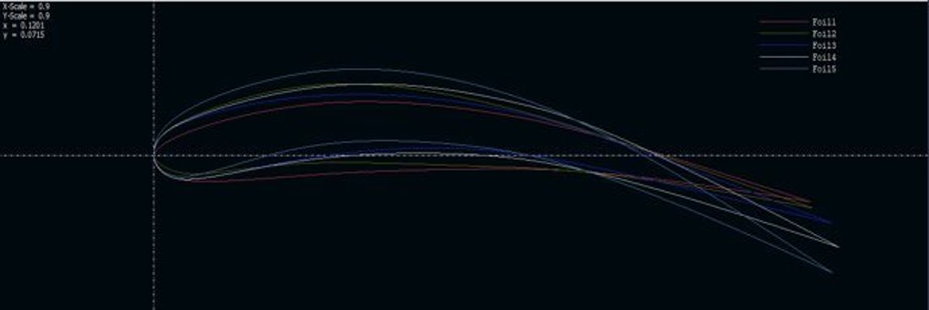

Figure 4: XFLR5 Airfoil Design Iterations

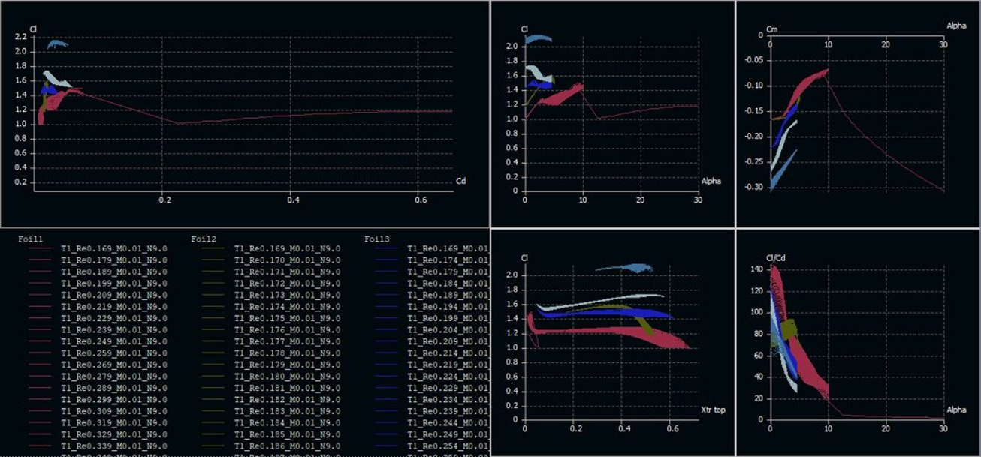

Figure 5: XFLR5 Iterative Analysis of Airfoils 1-5

Figure 5 represents plots of different parameters for each airfoil, swept between the range of the maximum and minimum Reynolds numbers. Based on these results, Foil 4, in white, was selected. Foil 5, in light blue, was not selected due to an unreasonably high coefficient of lift, which was determined to be an unrealistic computational output. Upon selecting Foil 4, much more complex analyses could be conducted in COMSOL. The shape of Foil 4 was exported from XFLR5 as a series of points to a comma separated value file, and then imported to COMSOL to retain the exact dimensions of the airfoil profile. To maintain consistency throughout both simulation programs, the Coefficient of Pressure (Cp) calculated along the surface of the airfoil in both programs was compared. The comparison between the two computational models would assert greater confidence in their accuracy should the results agree. The equation for Cp is stated below:

$C_{p}=\frac{\left(p-p_{∞}\right)}{\left(\left(\frac{1}{2}\right)*ρ*V^{2}\right)}$ (5)

Where $p$ is the pressure at the surface of the airfoil, $p_{∞}$ is the pressure at infinite distance from the location of measured pressure, which is 0, $ρ$ is the density of the working fluid (air), and $V$ is the velocity at the surface of the airfoil. The density of air at standard temperature and pressure, as previously stated, is 1.225 ${kg}/{m^{3}}$, and the velocity is determined computationally within the respective simulation programs.

Upon conducting COMSOL analyses of the airfoil behavior under the initial conditions defined in Equation 3, the following results were obtained:

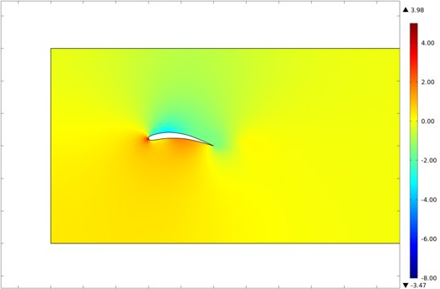

Figure 6: Coefficient of Pressure at 0° Angle of Attack

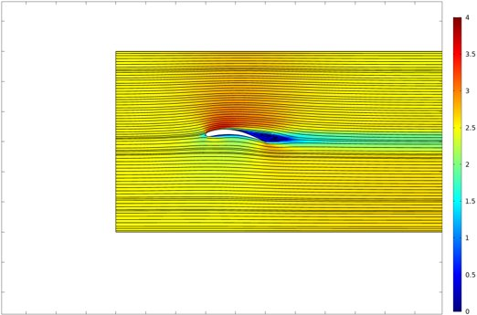

Figure 7: Velocity at 0° Angle of Attack

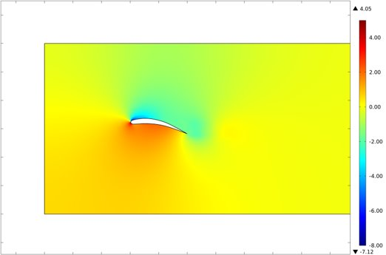

Figure 8: Coefficient of Pressure at 5° Angle of Attack

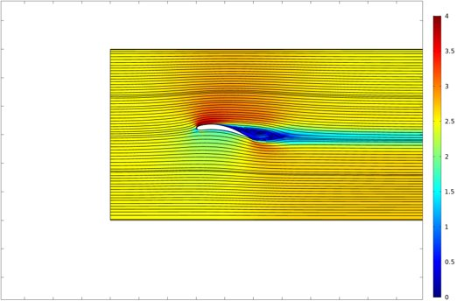

Figure 9: Velocity at 5° Angle of Attack

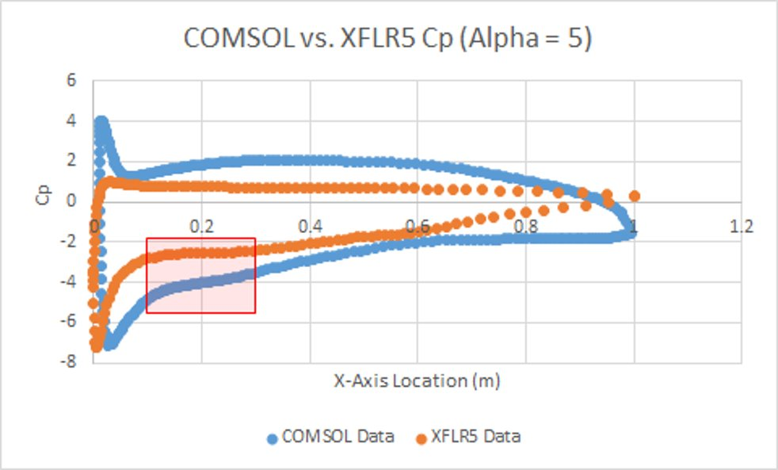

Figure 10: COMSOL vs. XFLR5 Coefficient of Pressure for 5° Angle of Attack

Figures 6-9 illustrate the COMSOL simulation results for a sweep across a range of Angle of Attack (AoA) values. There is a clear relationship between the magnitude of the Cp and velocity and the AoA. As the AoA increases, the Cp and velocity at the surface of the airfoil also increases in magnitude. The location of the greatest magnitude velocity and Cp also shifts toward the nose of the airfoil. Comparing the computed Cp along the surface of the airfoil from XFLR5 and COMSOL at an AoA of 5°, seen in Figure 10, there is agreement between the two simulation methods. The red highlighted area in Figure 10 indicates a region of data between both simulations that was consistent in having the lowest Cp value. This region was selected to feature the slot in the airfoil, as it would induce the greatest pressure differential.

The single airfoil analysis proved valuable in selecting an airfoil design, slot location, and verifying the COMSOL simulation as an accurate model when referenced against the XFLR5 data. Given this information, an analysis to determine the spacing between the airfoils could be completed. Figures 11, 12, and 13, below, display the results of the COMSOL airfoil spacing analysis: 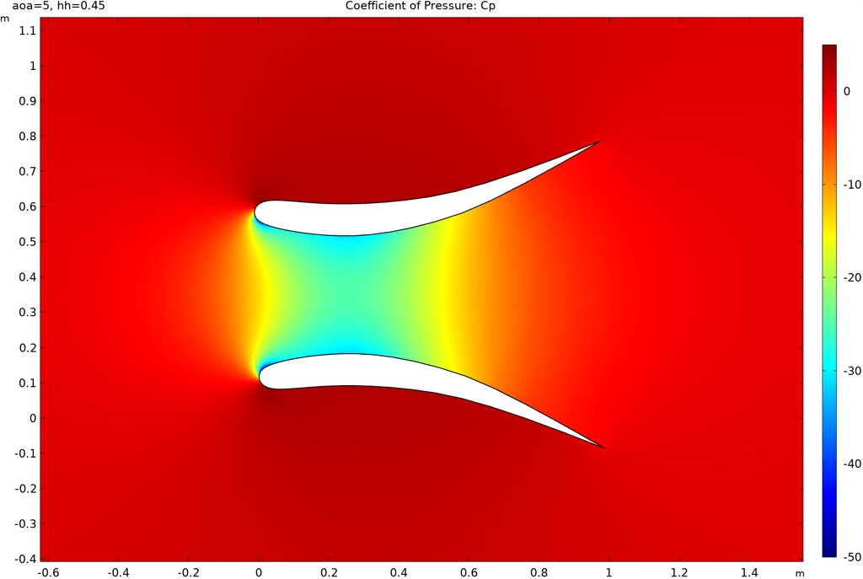

Figure 11: 45% Chord Length Spacing at 5° AoA

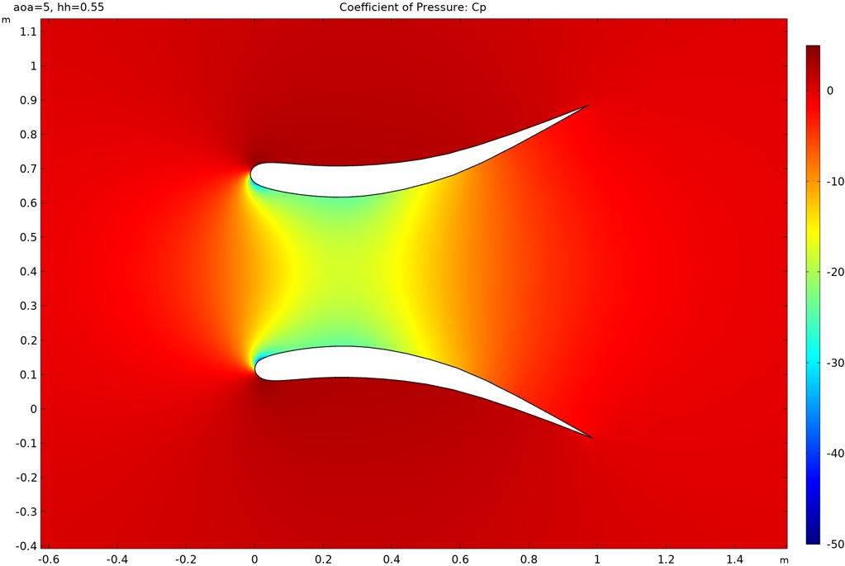

Figure 12: 55% Chord Length Spacing at 5° AoA

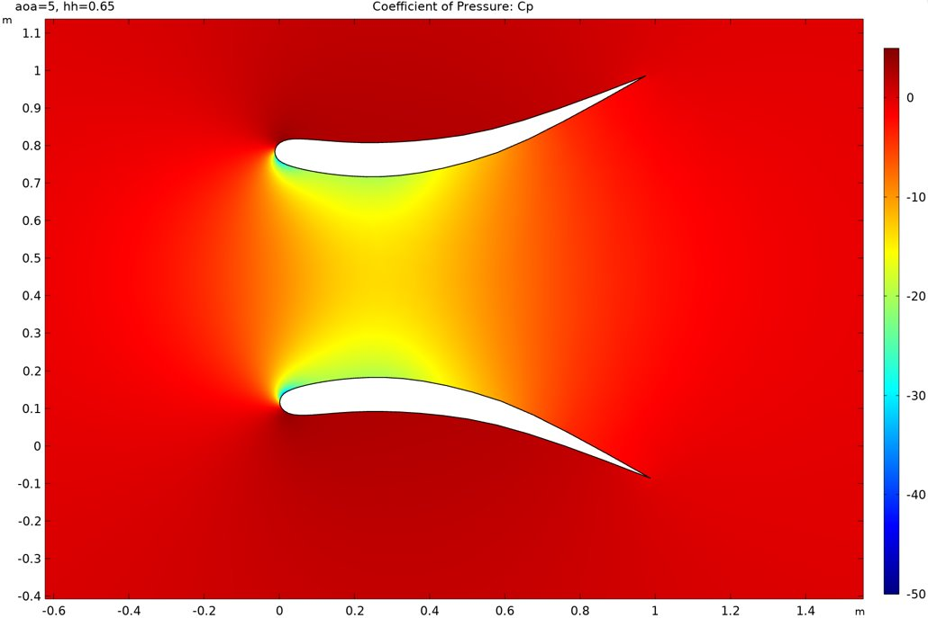

Figure 13: 65% Chord Length at 5° AoA

Upon examining the results from Figures 11-13, it was evident that there was an inversely proportional relationship between the Cp and the airfoil spacing. The 45% chord length spacing simulation resulted in the most desirable outcome for the BWES application. Decreasing the spacing below 45% of the chord length was determined to be inaccurate as a turbulent Reynolds Averaged Navier-Stokes study was used for the simulation. In this study, the airfoils could be brought infinitesimally close together, and the resulting Cp and velocity would proportionally increase, which would not be true experimentally. To verify the results of the COMSOL simulation, an experimental scale model was generated and tested in a wind tunnel.

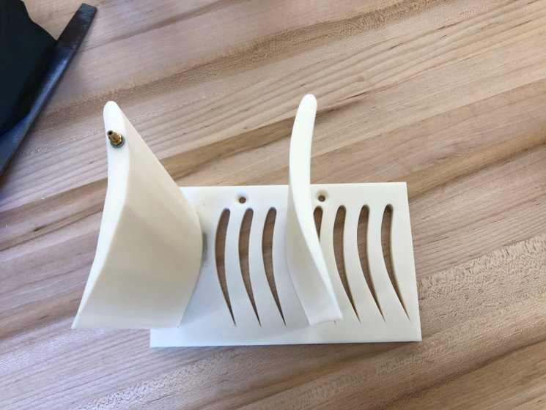

Figure 14: Scale Airfoil Model

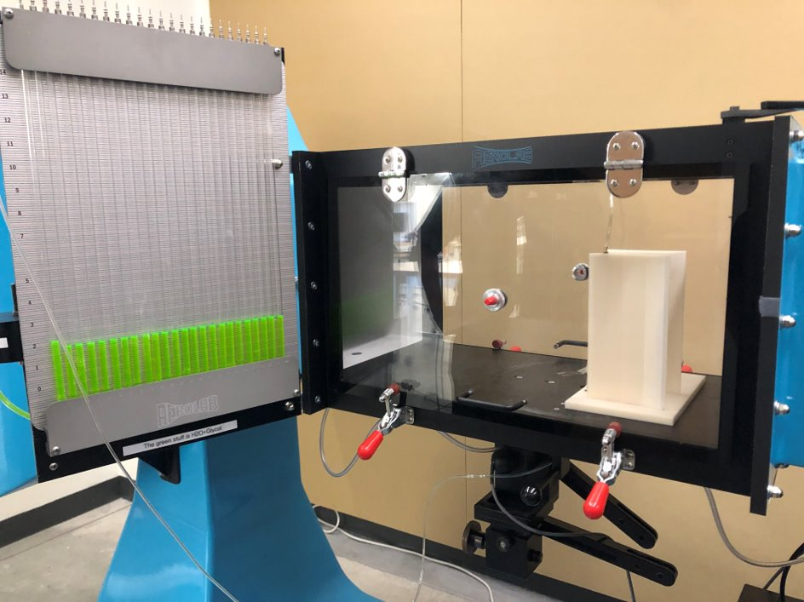

Figure 15: Wind Tunnel Airfoil Model Testing

The scale model had adjustable spacing in increments of 20% the scale chord length. The increments began at 10% chord length and went up to 150% of the chord length. The left airfoil was stationary and featured a pressure tap that ran from the top of the airfoil, down through the center, and out onto the surface where the pressure was measured. The pressure measurement location was where the slot location would be featured in the full-scale model. Another key feature of this test was that the airfoils could be rotated relative to the incident wind, simulating much greater AoA. This test featured AoA of -15° to 15° relative to the foil from which the pressure was being measured. The results were compiled, and the Cp was calculated for each test, seen in Figure 16, below.

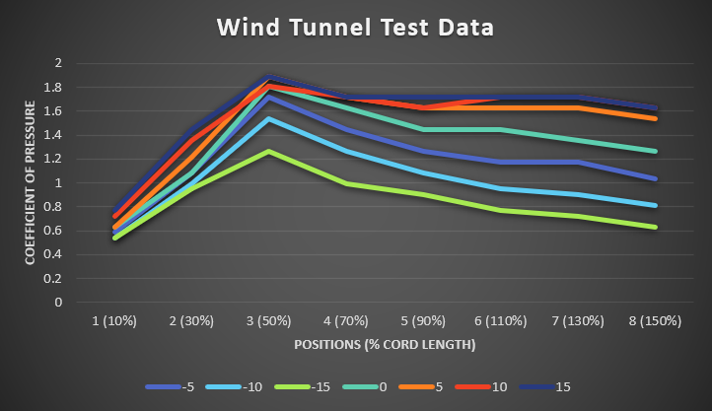

Figure 16: Wind Tunnel Test Results

In the test results above, 50% airfoil spacing produced the greatest magnitude Cp, as predicted by the COMSOL spacing analysis. This lead to great confidence in a 45% chord length spacing between the airfoils. Also, the wind tunnel test demonstrated a pressure gradient under all incident wind AoA. In the full-scale system, this implies that functionality is possible without incident wind that is parallel to the airfoils. The full-scale system will be operating under highly variable weather conditions, so perfect incident wind would almost never occur.

## Manifold

The purpose and goal of the manifold subsystem was to create a path that air could travel from the inlet at the turbine to and the outlets at the airfoils. The manifold selection needed two main components. First, the manifold needed to be built with a material with little to no friction to negate loss in the system. Second, the manifold had to somehow be split into two paths, so each path could be connected to the bottom side of the airfoil slots to allow air inside the manifold to be sucked out. The manifold was designed in such a way that it would be able to fit underneath the table in which the airfoils sat upon, so dimensions were critical.

For the first main component, material selection had to be considered. The team wanted something cheap, modular, smooth, and easily modifiable. Plastic PVC was the clear choice keeping those requirements in mind. The team decided to go with 3 inch PVC piping to create the manifold subsystem. It was relatively cheap, easily attached via joints and connections, very smooth (absolute roughness coefficient of $0.49-2.30 x {10}^{-5}$), and easy to cut to lengths necessary. 3 inch PVC piping was chosen because it is a relative size to the entire system (whereas 2 inch may be too small, and 4 inch may be too large). Holes needed to be drilled into the PVC for any water that might get in the system to be drained, which is a non-issue with PVC.

The second major component was the manifold needed to be split into two paths. Since the team decided on PVC, a decision had to be made whether to use a solid schedule 40 PVC (most common PVC used in piping), or a soft/flexible PVC tubing. At the time of deciding, airfoil space testing was not completed yet, so the spacing in which the airfoils were apart was unknown. Because of this uncertainty, the team decided to use flexible PVC tubing. This allowed for the flexibility of the length they are cut at, without having to worry about specific angles created by joints. To create the split in the manifolds, a double wye PVC joint was chosen, which splits the main path at an unknown angle (manufacturer did not provide the specific angle). Having the angle of the double wye and the spacing of the airfoils be unknown strengthened the reasoning behind purchasing the flexible PVC tubing as it can be bent at any necessary angle.

When modeled, the dimensions of the table designed were considered. The manifold needed to fit under the table while still performing the necessary functions of transferring air. A path was created that would allow the turbine/generator system to be attached at the inlet, and the two outlets were designed to be variable with the flexible tubing. Holes were designed to be cut into the PVC to allow for drainage towards the inlet of the manifold and the correct sized joints were utilized in the design. Overall, the manifold was successfully designed with little to no open issues.

## Turbine

In order to generate power, a generator was required to be attached to some sort of blade system at the inlet of the manifold. This subsystem needed to be efficient with low flow velocity, and needed to be able to attach to the inlet of the manifold without gaps for air loss. The design created was inspired by a car turbo. The modified design is efficient in low flow velocity and also efficient at a smaller scale. The reason efficiency matters at a small scale is because the system cannot have exposed blades. It cannot have exposed blades like a traditional wind turbine because suction is used as a method of rotating these blades. The flow velocity would be much too low for a large, open rotor blade design. Because of this there needs to be the most efficient blade possible at the smallest size. This design maximizes the torque at the shaft all while being extremely compact. In other terms, if the blade system was larger, there would need to be larger tubing in the manifold design which would result in lower velocities. If the blades were smaller, the piping in the manifolds would need to be smaller which would create a higher velocity, but the adverse effect would be the blades would not have a high enough torque to spin the generator.

Since there were specific design choices made, this design would have to be unique. It was decided that this would be 3D printed to allow for a completely custom turbine design to fit onto the manifold inlet with a very low tolerance. The blades in the turbine system could then be customized to fit the exact shaft diameter of the generator. 3D print material can easily be cut into if necessary, and it was planned so the hole in the blade shaft would be tapped so the generator shaft could easily be screwed in. This mitigates the risk of press fitting the generator into the blades, and potentially causing damage to the generator. Figure 16 below shows the completed design, where there is a set of turbine blades, an upper housing (which includes the tube that attaches to the manifold system), and a backing that holds the blades inside the system while also sealing the turbines for little air loss.

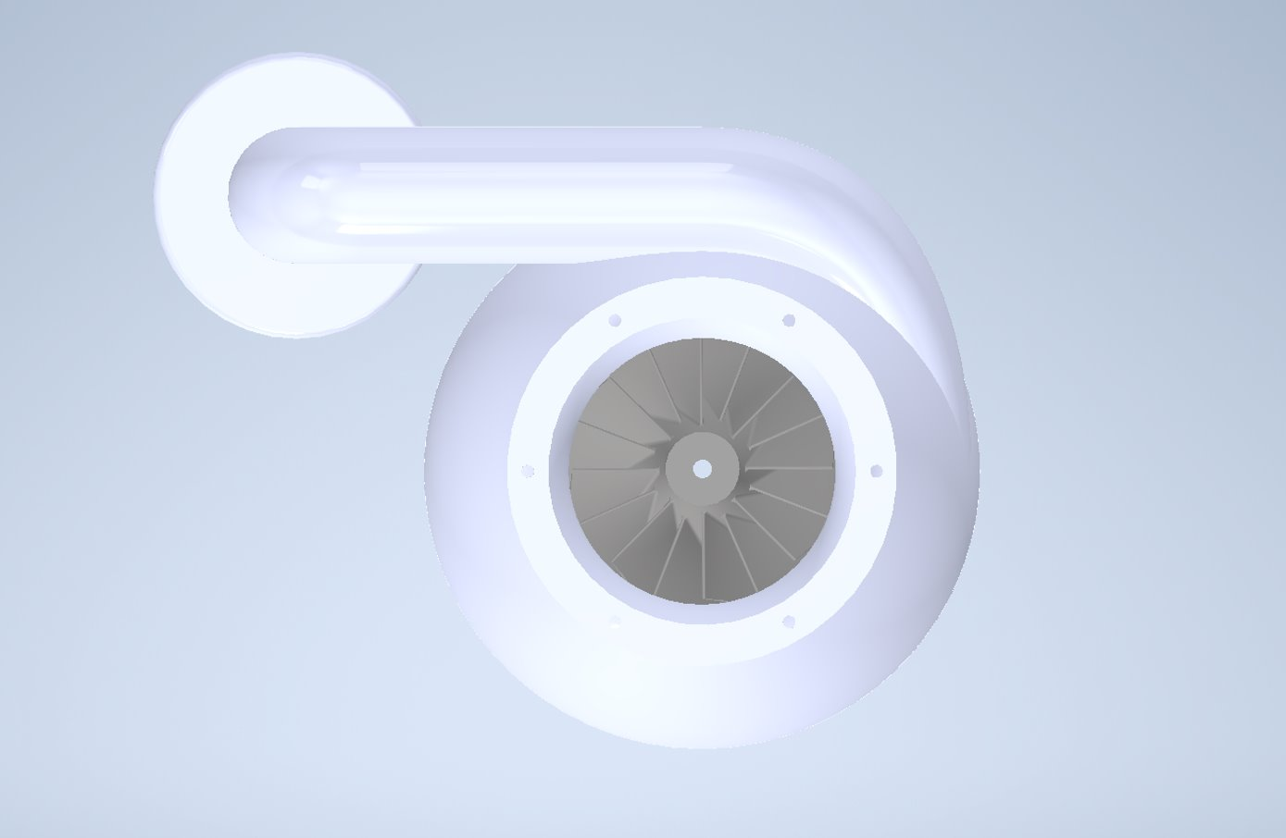

Figure 17: Turbine Blade Design

## Generator Circuit

The goal of the generator circuit subsystem is to successfully harness and store the electrical energy created by the spinning turbine on the generator. Furthermore, the system is responsible for controlling the power delivered to the battery, as well as displaying the wind speed, direction, and current draw from the motor onto a serial monitor.

The generator itself is a 12V 3000rpm rated motor in which the BWES team used as a generator. The original choice, as mentioned in the Chosen Design section of the report, was a 24V 3-phase AC generator. The team believed that this generator would theoretically be the best choice, as 3-phase AC is considered more efficient in energy systems. It was found during testing that the torque of this original generator was too high for the expected wind strength to overcome and turn the turbine. Thus, a replacement was found; given the time restrains, the team decided to proceed with a smaller, 12V DC motor with a much lower required startup torque.

The battery chosen for the circuit was a 12V 100Ah deep cycle lithium battery. The 12V battery is needed for the system to store the energy converted from the generator. Furthermore, a load can be connected to the system such that the BWES can potentially power a given system as seen below:

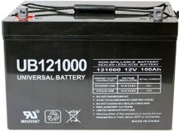

Figure 18: 12V Deep Cycle Battery

A deep cycle battery was chosen for the safety and reliability of the battery type. A deep cycle battery, given its complex construction of thick battery plates and denser inner materials, can withstand repeated charge and discharge cycles unlike the average car battery.

A 12V/24V DC charge controller was chosen as the current delivered to the battery and load from the generator needed to be regulated; without the charge controller, it is considered unsafe to directly connect a load to the 12V battery; arcing may occur, and thus it is critical to have a reliable charge controller in a charging system of any type.

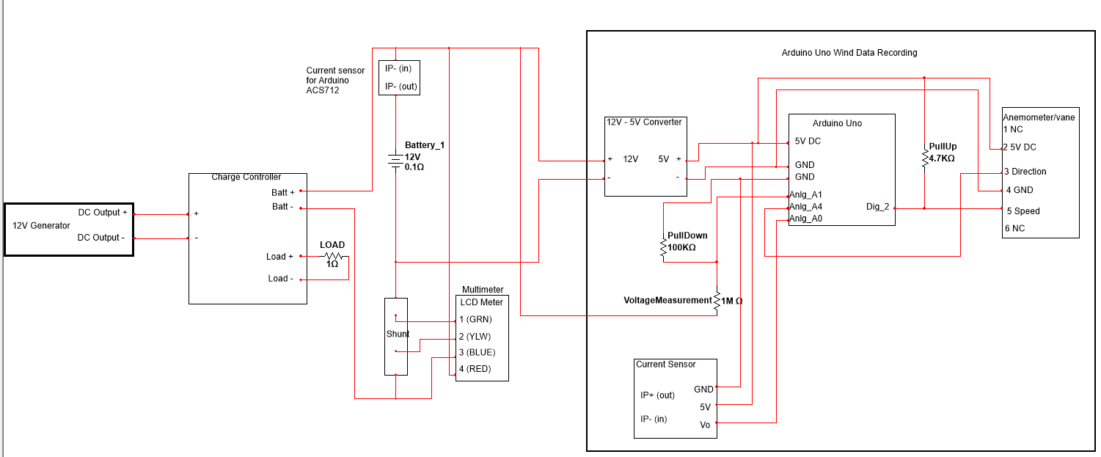 These components described can be seen in a National Instruments Multisim electrical schematic below.

Figure 19: Complete Electrical Schematic

Furthermore, a current shunt was connected in the battery circuit to allow the team easy visual confirmation of circuit current levels; these levels are displayed on the multimeter connected to the shunt.

In the diagram above, the Arduino Uno data monitoring circuit can be seen as well. The Arduino uno was couple with the Davis Anemometer for simply interfacing to the analog and digital pins on the Arduino. The Arduino Uno itself was designed such that it can be powered from the battery or through a direction connection to a laptop, in which the data can be displayed on a live serial monitor. In order to measure a voltage above 12V with the Arduino, a voltage divider was needed in order to scale down the voltage and then connect the Arduino to the divider output; the resistors are specified in the code as a 100kΩ connected to ground and a 1MΩ. $Voltage=\frac{input*100kΩ}{100kΩ+1MΩ}$, with the input variable being the value measured from the Arduino. We can rewrite the equation as $input=\frac{Voltage*(100kΩ+1MΩ)}{100kΩ}$. Thus, we are measuring the voltage that is going to our battery. The current sensor used was an ASC712 20A current sensor which connected between the Arduino and battery.

The Davis Anemometer used for the wind data provided wind speed and direction. Wind speed was connected directly to a digital pin on the Arduino Uno, as it used interrupts with a metal contact switch on the falling edge each time it makes one full revolution. A pullup resistor was added so there were no false triggers to the Arduino. The wind direction pin was connected to the A4 pin on the Arduino Uno, where it utilized a 0-360 mapping system.

## Code

The code for the BWES system needed to display wind speed, direction, current, and voltage levels of the system. The data would then be displayed on a serial monitor where the team can analyze the results. The wind direction and speed used data form the Davis Anemometer. The wind direction used a map function to convert the 2^10-bit signal from the Arduino and downscaled it so a 0-360 value depending; thus, the signal changed and updated whenever the direction vane sent a different electrical signal. The preliminary code snippet can be seen below:

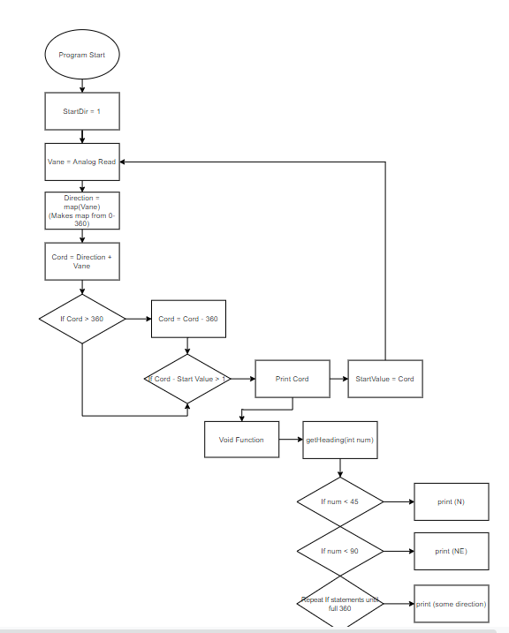

Figure 20: Wind Direction Code Flow Design

An appropriate heading can be displayed based on the value read from the Davis Anemometer. The design choice for the wind speed code structure was similar to wind direction, however it used a digital pin instead of analog on the Arduino Uno. The digital pin was needed because the Davis Anemometer speed cups used a mechanical switch for one full rotation. Thus, a signal would be triggered high and then low for a short amount of time; a digital signal process design was needed to properly read this differential signal.

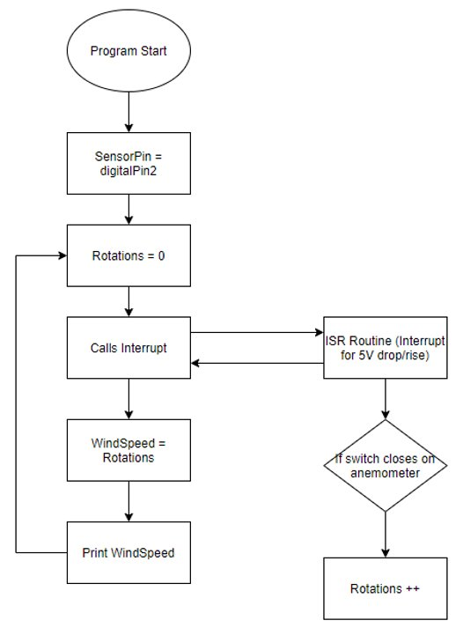

Figure 21: Wind Speed Code Flow Design

An interrupt routine was developed such that on the falling edge of the 5V pulse caused by the anemometer contact switch, a function would be called to update the number of rotations from the anemometer. This allowed the constant influx of new values from the wind vane if needed.

The current measurement of the system relied on the ASC712 sensor, in which the sensor provided the Arduino Uno a voltage level that relates to the current passing through the sensor and the battery circuit. The code environment used was Arduino App 1.8.13.

1. **Fabrication and Integration**

# Table

The table consisted of three main parts: plywood sheets, 2’ x 4’ supports, and 4’ x 4’ supports. The 4’ x 4’s were cut to size, and the top pieces had to be cut into to allow room for the 2’ x 4’s to sit inside them. The plywood sheets were marked and cut with a skill saw to the specified measurements. 6-inch lags were used to attach all necessary pieces and silicone caulking was used to fill any gaps. Figure 22, below shows a side profile of the completed table. Later, more plywood sheets were attached to the sides (as seen in Figure 3 earlier) and coated in Rust-Oleum leak seal, a flexible rubber coating. The coating allowed for the electrical system and manifolds placed inside to stay dry from elements. The reason the side sheets were not attached earlier was to allow for the entire system to be transported while it was as light as possible.

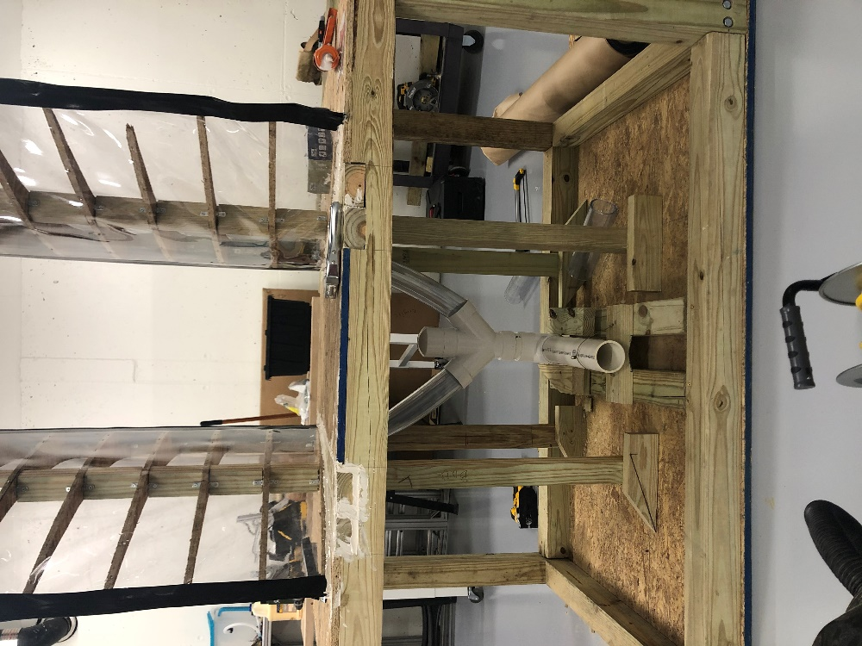

Figure 22: Table

# Roof

The fabrication of the roof took minimal time. There were three sections of support on the roof, two on the outsides and one in the middle. 2’ x 4s were cut according to specified angles from design. Each triangle needed three specifically cut pieces to make the triangle support, and plywood sheets were then cut to be laid across the supports to create a roof. A thin piece of plywood was cut from the larger sheets to cover the open space at the top of the roof. Wood glue and wood screws were used to hold the roof together. Finally, a plywood square was cut to create a base for the roof to sit on top of the airfoils. Figure 23 below shows the roof after it was installed on top of the airfoils.

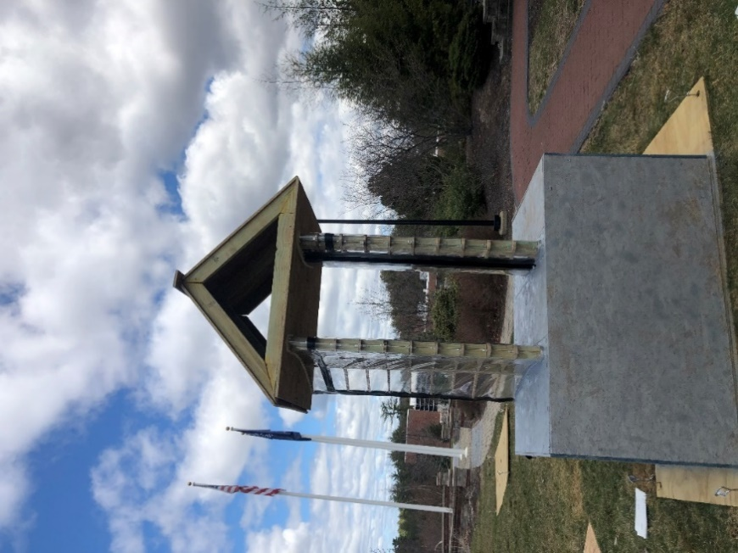

Figure 23: Completed and Installed Roof

## Airfoils

Fabrication for the airfoils consisted of many steps. First, the ribs (plywood cut with the profile of the airfoils) needed to be cut. To get an accurate cut for the ribs, a full-scale drawing was printed on poster paper. It was then cut out and traced onto a sheet of 4’ x 8’ plywood. A jigsaw was used to cut the first rib, and 22 had to made (11 on each airfoil). The first rib cut out was used as a reference for the following 21 ribs, and it allowed for easy tracing and the same profile every time. This concluded the cutting of the ribs for the airfoil.

The next piece of the airfoils that needed to be cut was the 2” x 4” wooden spars to connect all the ribs together. The 2” x 4” pieces were first cut on a table saw to match the profile of where they would sit on the ribs. After that, notches were cut into the cut 2” x 4” pieces to allow the ribs and spars to be connected. Once the four spars were cut, they were placed inside the table in the correct upright position. The holes for the spars were cut into the table using a pilot hole and a jigsaw. Once the spars were placed in the table, the airfoils were placed in each of the correct slots and lined up to create a full profile of the airfoil. To secure the ribs and the spars together, L brackets, half inch wood screws, and inch long bolt and nuts were used. An L bracket was used on the top and bottom of each of the ribs and on both sides of each of the spars. The half inch wood screws were used to screw the L bracket into the 2” x 4” spars. A small hole was drilled through the rib and a small bolt and nut was pushed through to connect the two L brackets on one side of the spars. In total, eight L brackets were used for each rib, including eight half inch screws, bolts, and nuts. The bottom two ribs were screwed into the table and the top two ribs were screwed down into the spars.

Next, a 4” x 4” square PVC pipe was cut with a table saw to fit into the slots in the ribs of the airfoils. The PVC piping was secured using L brackets, bolts, and nuts. The L brackets connected the PVC pipe to the plywood ribs of the airfoil. This was done to keep the PVC slot in place. After the rib's skeleton was constructed, the airfoils were wrapped in a clear malleable vinyl. This was done in three separate sections of the vinyl. The first section was placed at the back of the airfoil and wrapped around the front to the edge of the slot. The vinyl was then stapled into ribs using a heavy-duty construction stapler and was stapled approximately every six inches to ensure the vinyl stayed securely on the ribs. The next section of vinyl was then stapled from the back edge of the PVC slot and ran to the end of the airfoil. The excess vinyl was cut using a utility knife and stapled together. The ends of the vinyl were then taped over in black gorilla tape to ensure an airtight seal. The vinyl was folded over and taped to the inside of the slot.

The third section of the vinyl was placed over the entirety of the PVC slot and stapled to the ribs. The ends of this vinyl were then taped down to the other sections of vinyl to create an airtight seal. Holes were then cut out of the vinyl that was covering the slot at 1.5” x 3” in the shape of a rectangle. These holes were spaced out by 1.5” and ran up the entirety of the slot. With the airfoil being completely constructed, silicone caulking was used around the base and top of each of the airfoil to seal up the tops and bottoms of the airfoils to prevent water and air getting into the airfoil structure. Figure 24, below shows the completed airfoils:

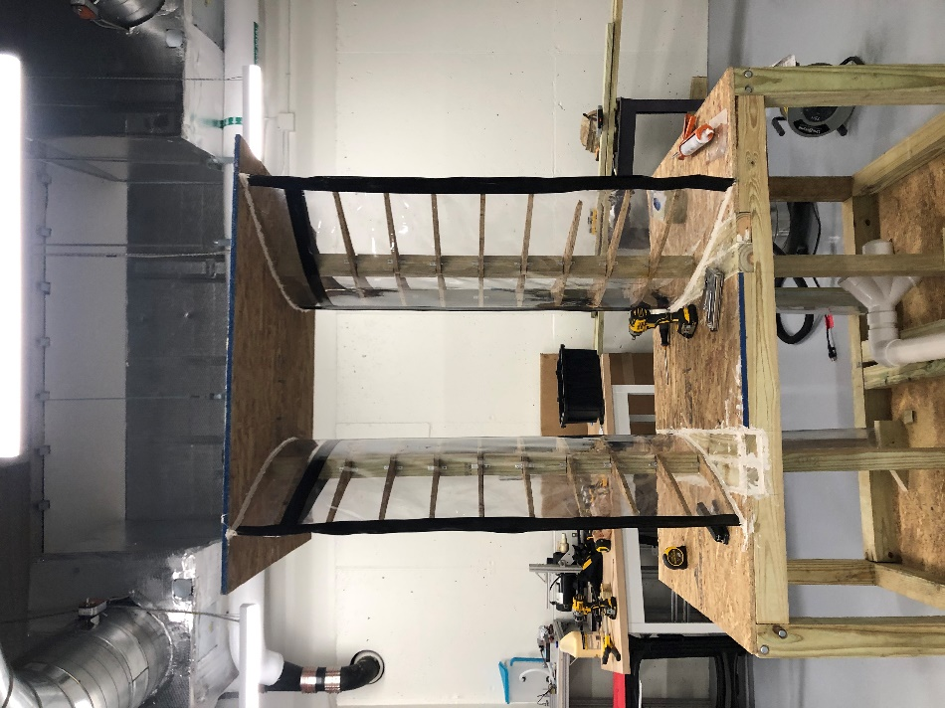

Figure 24: Completed Airfoils

## Manifold

The manifold consisted of only PVC parts which allowed for ease of installation. All PVC piping was cut down to size using a miter saw in the machine shop at CETA. The two upper piping systems that are clear were cut down the appropriate variable size necessary to fit under the table. All PVC cutouts were attached as needed, and PVC cement and caulking were used at all joints and connections to completely seal the subsystem. The two upper tubes were press fit into the bottom of the table and attached and sealed via caulking. Figure 25, below shows the built subsystem.

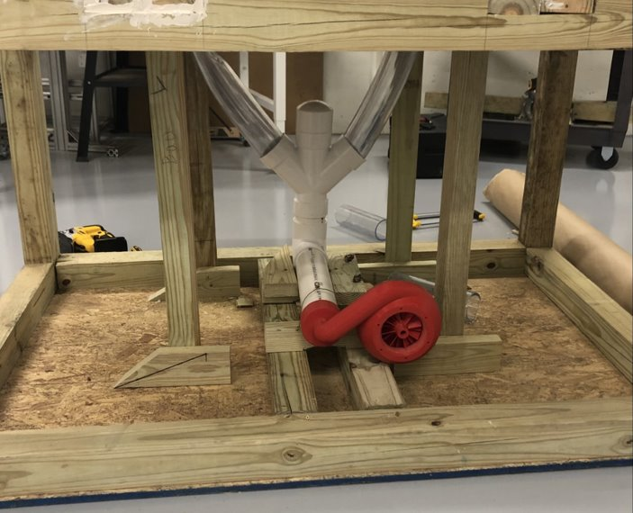

Figure 25: Completed Manifold System

## Turbine

The fabrication of turbine system utilized 3D printing and machine shop hand tools. The turbine was broken up into three parts: the turbine blades, turbine housing with tube, and the backing of the housing. The three parts were modeled to all fit with each other, and the tube attached to the turbine housing was designed to fit right over a 3-inch PVC which was used for the manifolds. Once the 3D printed parts were received, a hole was tapped in the turbine blades. This allowed for the generator to be screwed into the turbine blades with no worry of damaging the generator shaft.

When testing to see if all the components fit together, it was made apparent that the turbine blades would hit the turbine housing when the generator was rotating. To mitigate this, the inside edge of the turbine edge was sanded down to allow for additional clearance. After around an hour of sanding and testing, the turbine blades were able to spin freely in the turbine housing with no physical contact to the inside wall. Once this was determined, the generator was unscrewed from the turbine blades, and then Loctite (a thread locking solution) was added to the generator shaft. This would allow for the generator shaft to sit inside the turbine blades tightly with little to no movement. The turbine housing backing was attached to the housing, and the generator was re-screwed into the turbine blades. Caulking was used to seal the turbine housing and backing to seal all areas where air could be lost. At this point, the turbine subassembly was complete and ready to be attached to the manifold system. This was completed using Epoxy and caulking to allow for the 3D printed PLA plastic to adhere to the PVC. Figure 26, below shows the completed turbine system attached to the manifolds:

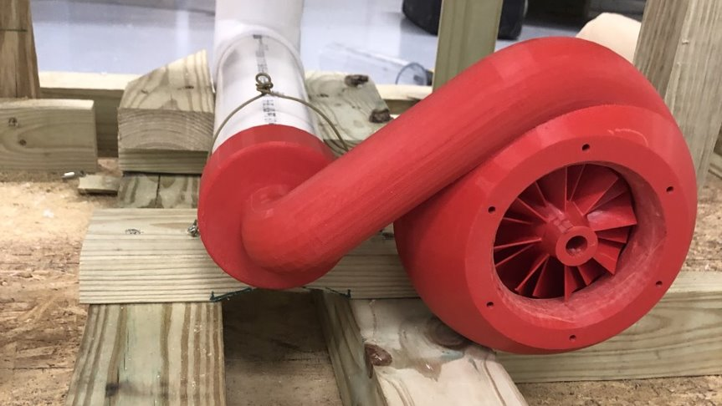

Figure 26: Completed Turbine System

## Generator Circuit

The fabrication and development of the electric circuit consisted of wiring and testing the complete electrical circuit subsystem. The team used 10-gauge wire for wiring the battery circuit, as 10-gauge can handle up to 30 amps. The charge controller within the circuit was wired first; the battery was then connected to the charge controller. The charge controller successfully recognized the 12V battery, and testing showed that current was able to be delivered to the battery form the BWES generator. A test load, being an electric drill, was connected to the load side of the battery charge controller to determine if the circuit and battery can provide a load current. This test was successful, as the electric drill load was able to draw 3A from the battery. The battery was then able to be recharged from the BWES generator with about 300mA delivered from the turbine rotation caused by a shop-vac. Furthermore, the code was responsible for the overall functionality of the Arduino Uno monitoring circuit.

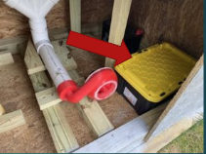

Figure 27: Electrical Circuit Placement

Once these preliminary subsystems tests were completed, the Arduino circuit was connected, and the full subsystem was placed into a weatherproof plastic bin shown in the image above. The battery itself is next to the plastic bin, but still protected from the elements within the BWES prototype.

## Code

The code for the BWES system was developed with the Arduino C++ environment version 1.8.13. The three central goals of the code were to measure, and display wind direction, speed, and current/voltage levels being delivered to the battery from the BWES generator. The wind direction and speed were taken from the Davis Anemometer.

First, the wind direction code was developed. The code utilized the analog read value from on A4 on the Arduino needed, which is an analog signal pin. The value of the analog pin, using the resolution of the Arduino Uno of 1023 bits (2^10), a map function was made to convert the incoming signal levels from 0-1023 to a 0-360 map and displayed calibrated compass headers; this essentially converts the analog signal into a directional signal that the BWES team could analyze.

This 0-360 value was only updated it the new value had a difference of 5 degrees or more than the previous value. The data would then be displayed on a serial monitor where the team can analyze the results.

The wind speed code utilized the contact switch from the Davis Anemometer; once one full rotation was a made from the speed cups, a trigger would cause a 5V signal to be delivered to the Arduino. In order to convert this to MPH, an equation from the anemometer specification sheet who’s that the windspeed is equal to rotations * 2.25/T), with T being our sample period. In the case of BWES, the team decided to sample a signal once every 6 minutes. Converting this value to m/s the following equation was used: $Speed \left(m/s\right)=\frac{Rotations*2.25}{Sampling Period \left(s\right)*2.237(\frac{mph}{\frac{m}{s}})}$.

The current measurement of the system relied on the ASC712 sensor, in which the sensor provided the Arduino Uno a voltage level that relates to the current passing through the sensor and the battery circuit. The code snippet can be seen below.

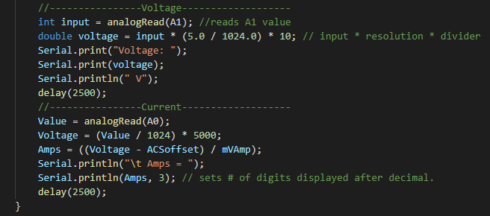

Figure 28: Voltage and Current Code Snippet

In order to measure a voltage above 12V with the Arduino, a voltage divider was needed in order to scale down the voltage and then connect the Arduino to the divider output; the resistors are specified in the code as a 100kΩ connected to ground and a 1MΩ resistor. $Voltage=\frac{input*100kΩ}{100kΩ+1MΩ}$, with the input variable being the value measured from the Arduino. We can rewrite the equation as $input=\frac{Voltage*(100kΩ+1MΩ)}{100kΩ}$. Thus, we are measuring the voltage that is going to our battery. The current reading was simpler, as it was the voltage reading from the ASC712 sensor to the Arduino and converted to Amp. The ASoffset and mVAmp variables were both defined from the sensor data sheet.

1. **Final System Test Results and Discussion** (Did the integrated system meet requirements?  Why or why not?

The final system test of the proof-of-concept BWES prototype final test data can be shown below. The Arduino Uno was directly connected to a nearby laptop and was displayed on a serial monitor for the duration of the final test. The wind speed and direction, as recorded by the Arduino Uno from the Davis Anemometer, can be seen with each data point being 6 minutes apart from each other. In other words, the sampling period was 6 minutes and was specified in the Davis Anemometer conversion equation from voltage to mph. This value of mph was then converted to m/s to allow the team to compare the results with the BWES requirements. The north bound component was then calculated. The highest north bound component is highlighted in red below.

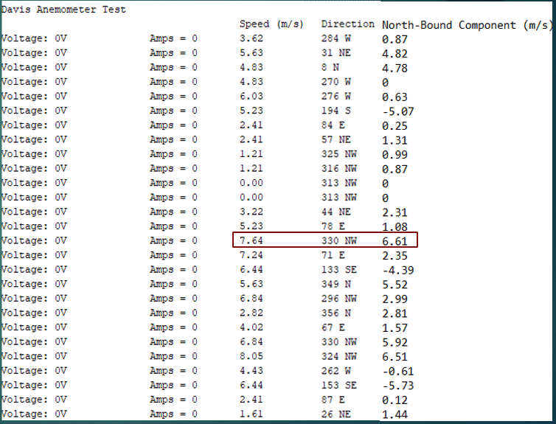

Table 9: Final System Test Data

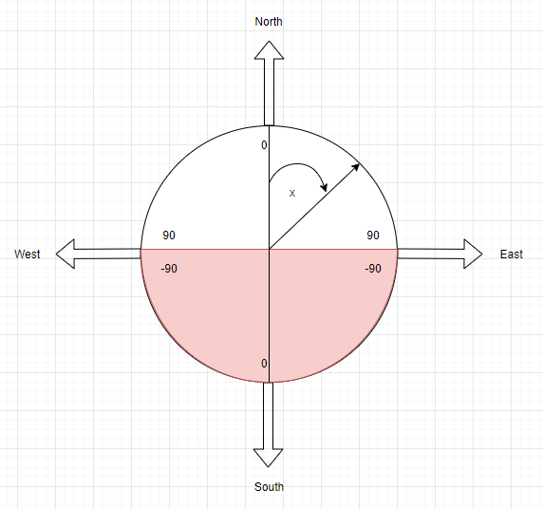

Figure 29: North Component Calculation Graph

It is important to note that the direction of North is not true North; it is north relative to the coordinate system of the BWES prototype in its location. This was to allow the team to have a consistent value to look for to see if the wind was blowing directly over the airfoils as designed. Thus, the North direction displayed is the most likely data sample in which the BWES would show electrical charge, since the wind over the airfoils would cause a low-pressure zone induced rotation of the turbine blades connected to the generator. This can be seen in the image below which shows the direction of “North” in this case. The North-bound component of the wind was calculated by multiplying the magnitude of the wind speed by cosine of the angle illustrated in Figure 29. The four quadrants determine whether or not the x-value (the angle in degrees) is positive or negative.

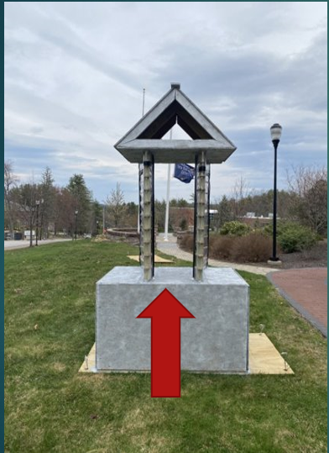

Table 10: Calibrated North for Final Test

Regardless of the direction, there was no voltage or current generation for the duration of this final test. After team discussion, it was agreed that the system itself can be functional with enough wind speed; this was proven in the prior lab test with the shop vac turning the generator turbine and generating electricity. Thus, a wind speed exists between the highest shown North bound speed shown in the above results (6.61m/s) and the wind speed created from the shop-vac in which the system functions as intended.

Another major consideration that was Another major consideration that was brought up in the team discussion was that the location was suboptimal for the BWES prototype. The location of the prototype can be seen below, marked on the map with a circle.

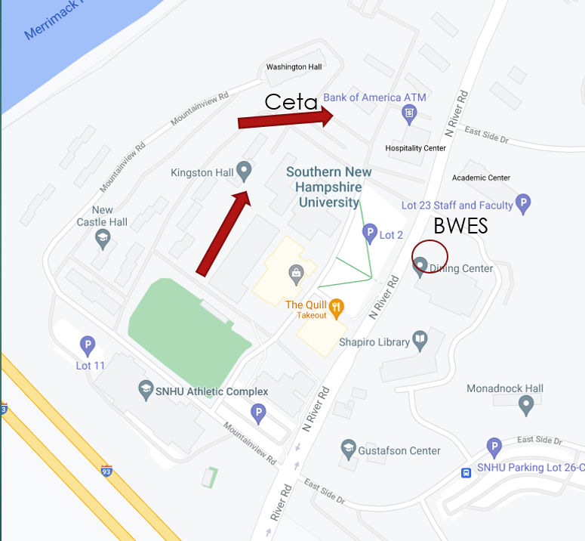

Figure 30: BWES Installation Location

The location itself was not optimal due to several reasons; the main reason was that the system was extremely close to the Dining Hall on campus. Furthermore, the topography was not ideal for any type of wind energy system. Originally, the team desired to have the system installed on the 3rd flow patio of the CETA building; however, after discussion with the building management and customer, this was deemed unsafe and the backup location next to the Dining Hall was used.

There were several requirements of the BWES proof of concept system that were not met. The first major requirement not met was BWES-11 and BWES-12. While electrical energy was generated in the lab test with the shop-vac, the final outdoor system test results did not meet this requirement of minimum atmospheric wind strength of 2.5m/s. BWES-12 relied on the generator being able to output a certain amount of power. While the first generator chosen (24V 3-phase) could generate this much power, the startup torque was too high for the system. The second choice was a smaller 12V motor that had a max output of 30W. Thus, this power requirement was not met as the system was modified. This connected to the two requirements BWES-04 *Energy Storage* and BWES-05 *Charging System*. BWES-03 specified two 12V deep cycle batteries shall be charged. With the change in generator to a 12V instead of a 24V, this was not feasible for the team. One battery was instead charged to match the 12V output. BWES-05 is the requirement of generator choice: 24V 3-phase generator. While the concept of a generator was met, a modified system resulted in the requirement being met with modification.

1. **Conclusion and Lessons Learned**

The central findings from the BWES prototype final test highlighted the location and its effect on pressure change within the system. The variable topography and limited location selection of the project resulted in a less than ideal location for the BWES prototype: next to the large dining hall building. It was agreed that the system itself can be functional with enough wind speed; this was proven in the prior lab test with the shop-vac turning the generator turbine and generating electricity. Thus, a wind speed exists between the highest shown North-bound speed shown in the above results (6.61m/s) and the wind speed created from the shop-vac in which the system functions as intended.

The location would be the main integration change if the project were to be repeated. A location with higher wind speeds should be scouted first; this may extend off campus in order for the project to be successful. This would, however, be discussed with the customer for prior approval for off-campus location.

The team learned a lot from this project, as it was a very difficult aerodynamic problem that had many complexes. The team is happy with the experience gained from this project, and hope that while the project itself isn’t meeting the power requirements at the installed location near the dining hall, that the proof of concept at least helped SNHU in their future endeavors in navigating eco-friendly energy options in their goal for becoming a carbon-neutral campus.

# **Recommendations for Continuing Project Work**

The team discussed thoroughly what would benefit the project in future revisions and continuing the project. One recommendation would be to perform greater analysis on the effect of scale. In the beginning of the project, the BWES team was unsure of the dimensions of the project. This would benefit the prototype early on in the design phase of the project. This would gauge the project design when it comes to the size of the airfoils, manifolds, and possibly a relationship between the two.

Since the BWES team had to switch to a second generator with lower torque for the team, it was discussed that investigation into torque and expected wind strength early on in the project. This would require more analysis of the forces needed from the pressurized wind flow to turn the generator turbines. Analysis on friction of the generator itself could also prove useful.

When it comes to a realistic test, it was difficult for the BWES team to simulate strong winds that would mimic an area with high average wind speed. Thus, a large-scale wind tunnel test would prove very useful; this would allow the team to see the direct wind strength required to make the system function properly. This testing could either be done at a nearby facility, or if SNHU had a larger wind machine.

Developing a realistic full system test or simulation may also prove useful to system like the BWES prototype: using the dimensions of the system’s subsystems such as manifold and airfoil design could be used as a model within a simulation. Thus, a wind vector could be created in the simulation and flow through the system. This would allow pre-fabrication test of the system’s performance in terms of pressure zones.

# **Appendices**

## Appendix A:  Schedule

|  |  |  |
| --- | --- | --- |
| **Schedule** | **​**​ | **​**​ |
| **Milestones** | **Date Range** | **Description** |
| **System Requirements and Conceptual Design** | 9/30/2020 - 10/15/2020 | Project proposal rough and final drafts, and conceptual design was created. Essentially the concept of entire project. |
| **Preliminary Design** | 10/16/2020 – 11/12/2020 | Drawings, calculations, 3D CAD model, and presentation made for first design to be shown to customers. |
| **Detailed Analysis and Design** | 11/13/2020 – 11/24/2020 | Make improvements on preliminary design with final measurements and drawings, a final 3D CAD model, in depth simulation (COMSOL), and any additional calculations. This is also considered the critical design review and included a presentation and report. |
| **Fabrication Readiness** | 11/25/2020 – 1/22/2021 | Completed bill of materials and created drawings and design instructions for fabrication. Ordered parts once BOM was completed. |
| **Final Prototype** | 3/18/2021 - 4/16/2021 | Full fabrication and system of entire prototype. |
| **Test Readiness Review** | 4/16/2021 - 4/19/2021 | Tests performed on prototype, data analyzed, and presentation made. |
| **Final Presentation** | 4/20/2021 - 4/27/2021 | Summarized entire capstone project into one presentation. |

## Appendix B: Financial Summary

Overall, the BWES spending remained below the teams maximum allowed budget of $3000. The total cost of the BWES was $2363; the majority of this budget spent was spent from the mechanical hardware expense section. This included all the plywood sheets, 2’ x 4’s, and 4’ x 4’s that made up the structure of the BWES. The chart below shows the final budget update from the BWES team.

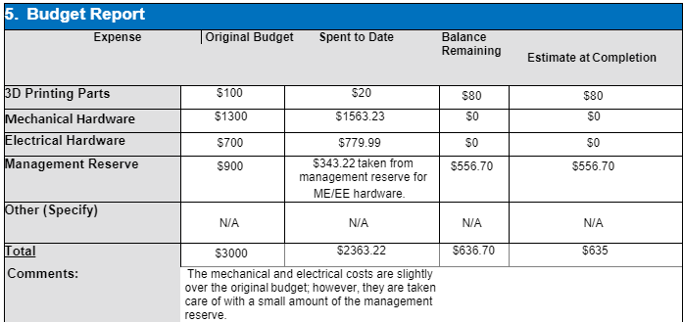

Table 11: BWES Budget

The electrical hardware, including the deep cycle batters and generator, cost about $779 in total; this went $79.99 over the allotted budget for electrical components; however, it was covered by management reserve. 3D printing some parts was relatively inexpensive; this covers the turbine blade subsystem that connected to the manifold. In summary, the BWES system stayed under budget with some additional parts and tools leftover.

## Risks and Mitigations

|  |  |  |  |  |  |  |
| --- | --- | --- | --- | --- | --- | --- |
| **Risk:​**​ | **Likelihood of Occurrence​**​  **(1-5):​**​ | **Risk**  **Importance ​**​  **(1-5):​**​ | **Function​**​  **(1-5):​**​ | **Cost:​**​ | **Trigger:​**​ | **Mitigation(s): ​**​ |
| **Risk #1)​**​ **Insufficient Power​**​ | 1​​ | 5​​ | 4​​ | 3​​ | Lack of proper air flow to the generator​​ | Redesign manifolds leading to generator​​ |
| **Risk #2)​**​ **Manufacturing failure​**​ | 2​​ | 3​​ | 4​​ | 1​​ | Broken part of system during  manufacturing   process. ​​ | Order additional parts that may be fragile or difficult to machine. ​​ |
| **Risk #3) Water/Snow Damage​**​ | 3​​ | 3​​ | 5​​ | 1​​ | Water or snow leaking into the tubular airflow routes of the apparatus​​ | Design the internal passages and inlets such that snow would slide off the apparatus and water to properly drain out from the system. ​​ |

Table 12: System Risks and Mitigations

## Code

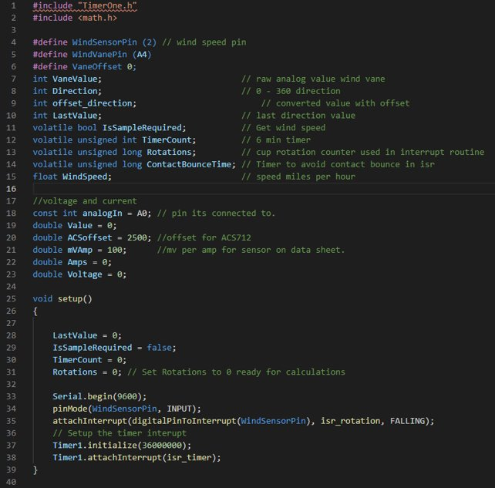

Figure 31: Code 1/4

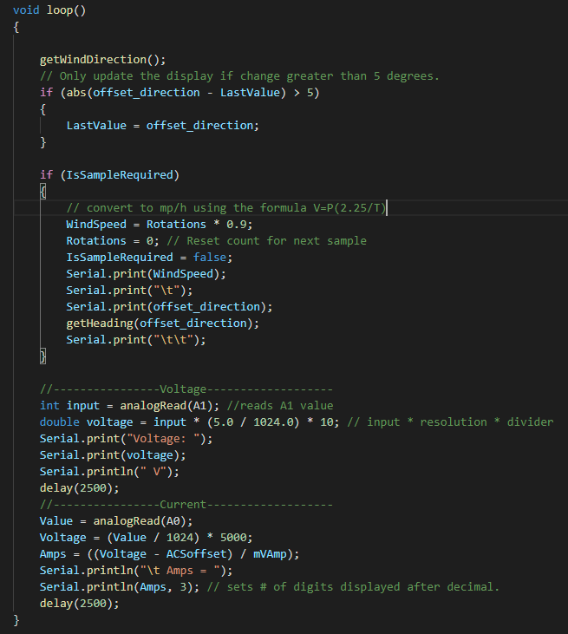

Figure 32: Code 2/4

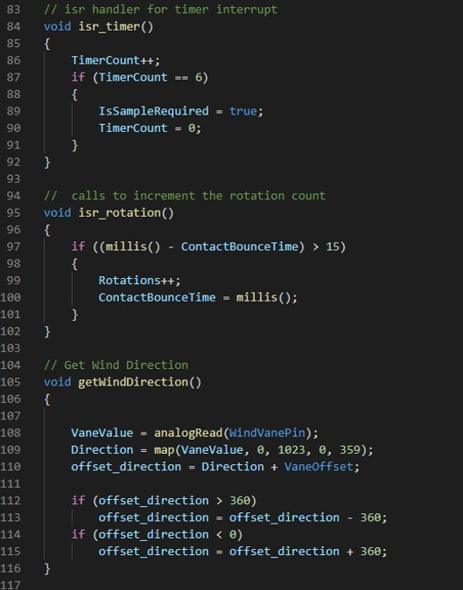

Figure 33: Code 3 / 4

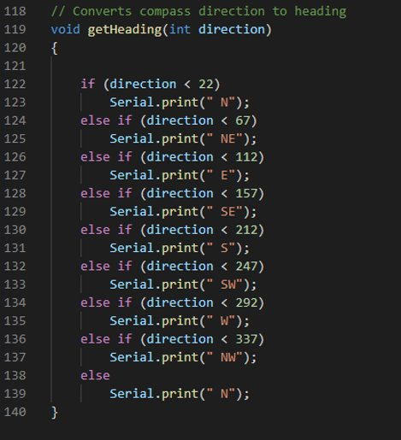

Figure 34: Code 4/4

# **References**

Jayadev, T S. *Induction generators for Wind Energy Conversion Systems. Part I: review of induction generator with squirrel cage rotor. Part II: The Double Output Induction Generator (DOIG). Progress report, July-December 1975*. United States.

Supardi, A., & Dzikri, N. M. (2019, June 26). A prototype of low power permanent magnet generator for renewable energy applications. Retrieved from <https://aip.scitation.org/doi/10.1063/1.5112494>

U.S. Energy Information Administration - EIA - Independent Statistics and Analysis. (n.d.). Retrieved from <https://www.eia.gov/energyexplained/electricity/how-electricity-is-generated.php#:~:text=In> a turbine generator, a relationship between magnetism and electricity

Verde, A., Lastres, O., Hernández, G., Ibañez, G., Verea, L., & Sebastian, P. J. (2018). A new method for characterization of small capacity wind turbines with permanent magnet synchronous generator: An experimental study. *Heliyon*, *4*(8), e00732. <https://doi.org/10.1016/j.heliyon.2018.e00732>